PROJECT TITLE: Barstow/Dumont Dunes CXT Janitorial

Contents
PWS 1.0 Background on the Government’s Requirement
PWS 2.0 General Scope of Work
PWS 3.0 Overall Objective(s)
PWS 4.0 Specific Tasks
PWS 5.0 Delivery / Performance Schedule
PWS 6.0 Government-Furnished Property, Materials, Services
PWS 7.0 Security and Administrative Matters
PWS 8.0 Technical Exhibits and Definitions
EXHIBIT X: Performance Requirements Summary

PWS 1.0 Background on the Government’s Requirement

Barstow Field office requires a new vault toilet maintenance and cleaning contract. This is a non-personal services requirement the contractor will provide the equipment, labor, and supplies to provide cleaning and stocking of twenty-five vault toilets during the anticipated time period at three (3) OHV Recreation sites which are Johnson Valley, Stoddard Valley, and Dumont Dunes. The areas for vault toilet services can experience extremely hot weather of over 100 degrees at any time.
PWS 2.0 General Scope of Work

A concise explanation is weekly CXT vault toilet cleaning, sanitizing, and stocking. The “what”, the ability to have the capacity to haul with a four-wheel drive half-ton truck a minimum of a 100 gallons of water, gas powered pressure washer, sufficient amount of toilet tissue, and cleaning supplies to each site for cleaning purposes. Have the dependable labor to be available for weekly cleaning and resupplying each vault toilet.

The contractor shall accomplish and deliver a clean, sanitized, and properly stocked vault toilet with toilet tissue on or before Thursday at 4:00pm PST. Contactor will forfeit payment for tasks not completed by 4:00pm PST on Thursday of service period.

Place of Performance:

Barstow Field Office toilets are located at Johnson Valley OHV area, Stoddard Valley OHV Area, and Dumont Dunes OHV Area. All service areas are extremely remote locations without access to utilities to include water and electricity. All the services described will be provided at every vault toilet at the previously mentioned locations. Maps of vault toilet locations attached.

Location/Direction/Number of Vaults:
Johnson Valley OHV Open Area: Johnson Valley is a remote desert area that contains rocky, soft sand, footing obstacles, and elevation changing trails that can be extremely difficult to navigate to access CXT vault toilets.

1) Bessemer Mine Road site #1., located off Hwy 247 approximately 47 miles south of Barstow, Ca. 2 Single-vault units.
2) Cougar Buttes site #2. located off Camp Rock Road on Granite Road, 2 Single-vault units
3) Anderson Dry Lake Site #3, located off Camp Rock Road, 1 Single-vault.

B. Stoddard Valley OHV Open Area: Stoddard Valley is a remote desert area that contains rocky, soft sand, footing obstacles, and elevation changing trails that can be extremely difficult to navigate to access CXT vault toilets.

1) Outlet Center Drive Site #6 located off Sidewinder Road. 2 single-vault units
2) Hodge Road #5 off interstate 15 Freeway in Stoddard Valley OHV open area 1 single vault.

C. Dumont Dunes Area: North of Barstow, CA off Highway 127 north towards Death Valley in San Bernardino County, California. Dumont Dunes is a very remote OHV area with very minimal cell service. Dumont Dunes OHV Area is mostly made up of extremely deep soft sand making it very difficult and challenging to access CXT vault toilets.

1) Little Dumont Dunes 1 & 2 has two single vault units
2) Dumont Dunes 3-12 has Ten single-vault units
3) Dumont Dunes Command Post One double-vault unit
4) Fee Station One (1) Single-vault unit
5) Salt Creek, One (1) Single-vault.

Period of Performance:

The period of performance shall be for one (1) Base Year of 12 months and four 12-month option years. The Period of Performance reads as follows:

PWS 3.0 Overall Objective(s)

The objective of this work is to provide and maintain clean, sanitized, and supplied vault toilets at the various difficult to access recreation sites throughout the Barstow Field Office managed area.

PWS 4.0 Specific Tasks

Furnish equipment, labor, and supplies to provide cleaning of up to 25 “CXT” vault toilets during the anticipated time period at three OHV Recreation sites: Johnson Valley, Stoddard Valley and Dumont Dunes with the vault at Salt Creek Day use area. As depicted on attached maps.

Task 1:
Physically inspect building exteriors for debris and sweep exterior concrete floors. Interior will be pressure washed with fresh water and a biological cleaning product. Floor area for single vault toilets is 80 square feet and double vault toilets are two 80 square feet areas. Tri-Synergy BB900 or equivalent will be used as a cleaning agent. All cleaning supplies must be in accordance with 52.223-1 and be environmentally safe and safe for the wildlife. All fixtures include but not limited to the toilet riser (inside and out), toilet seat, door and doorknobs, walls, windows (most have two windows with less than 20 Sq. Ft. surface area inside and outside).

Task 2:
Toilet tissue will be checked and replaced with new toilet tissue as necessary at the time of each service. Toilet tissue rolls need to meet a minimum post-consumer recycled content of 20-60% and total recovered paper fiber or total recovered content of 20-100%. All toilet tissue must meet the standard of FAR 52.223-1 and be environmentally safe and safe for the wildlife.

Task 3:
Remove all foreign material inside, on top of it, and within a 15-foot radius of each vault toilet. Remove all non-BLM stickers, clean building interiors, including walls, partitions, windows, pipe chases and ceilings. Remove all mildew, webs, and insect nests. Clean and disinfect all toilet risers and seats. Remove graffiti off all surfaces using graffiti remover. Clean exterior walls and roof projections including louvers over windows. No harsh chemical cleaners are to be used. No cleaning chemicals, containers or trash of any kind will be disposed of in the vaults.
a.) No hazardous materials shall be stored or disposed of on-site (e.g., fuel, oil, grease, etc.)
b.) Prevent or reduce the discharge of pollutants to the environment by reducing the chance of spills through safe operating practices, maintaining equipment, stopping the source of spills, containing, and cleaning up spills, properly disposing of spill materials, and training employees. In the event of a spill, the contractor shall excavate the impacted areas to a depth of 12-inches beyond the contaminated materials and backfill with approved material. The excavated contaminated material shall then be disposed of at a certified hazardous waste facility.

Task 4:
Dispose of all trash and debris at an approved facility that is off BLM land.

PWS 5.0 Delivery / Performance Schedule
The contractor must carry a minimum of 100 gallons of water, gas powered pressure washer, and other supplies into remote and difficult to access locations. A four-wheel drive, minimum of a half-ton or larger pickup truck is a requirement to be an acceptable contractor. A two-wheel drive vehicle for transport is not acceptable or approved to meet the minimum standard for this contract.

Johnson Valley and Stoddard Valley OHV area vault toilets shall be cleaned once a week from October 1st - April 30th on or before Thursday of each week. Two cleanings per month will occur on or before the first and third Thursdays of the month between May 1st - September 30th from the time of contract award throughout the performance period for that contract year. All tasks must be completed by 4:00pm PST on Thursday for each scheduled cleaning to avoid forfeiture of payment. Cleaning after this time will not be accepted.

Dumont/Salt Creek sites shall be cleaned once a week from October 1st- March 31st on or before Thursday of each week. Two cleanings per month will occur on or before the first and third Thursdays of the month between April 1st- September 30th from the time of contract award throughout the performance period for the contract year. All tasks must be completed by 4:00pm PST on Thursday of each scheduled cleaning to avoid forfeiture of payment. Cleaning after this time will not be accepted.

During 5 holiday weekends per year the Dumont Dunes/Salt Creek sites shall be scheduled for three cleanings each for the following holiday weekends: Halloween, Thanksgiving, New Years, Martin Luther King Jr. Day, and Presidents’ Day. The cleanings are required on Thursday, Saturday morning, and Monday morning during all 5 holiday weekends. The holiday weekends that require additional cleanings are as follows: Halloween, Thanksgiving, New Year’s, Martin Luther King Jr. Day, and Presidents’ Day. Holiday cleaning tasks must be completed by 4:00pm PST on Thursday, Saturday, and Monday to avoid forfeiture of payment.

PWS 6.0 Government-Furnished Property, Materials, Services

General:
The Contractor shall furnish all personnel, materials, equipment, supplies, facilities, transportation, tools, materials, supervision, and other items and non-personal services necessary to perform the work tasks defined in this Performance Work Statement, except for those items specified as government-furnished.

Materials:
The Government shall not furnish any materials.

Equipment:
The Government shall not furnish any equipment.

Utilities
The Contractor shall not furnish any utilities.

PWS 7.0 Security and Administrative Matters

Regular Work Hours:
The performance period established for this contract is based upon all work being conducted during regular working hours between 7:00am and 4:00pm, Monday through Friday, excluding government holidays. The contractor shall not carry on work outside regular hours, including Saturdays, Sundays, and government holidays, except for scheduled Holiday cleaning at Dumont Dunes/Salt Creek area, a request must be submitted to the Contracting Officer in sufficient time to allow satisfactory arrangements to be made for access to the work site.

Communications:
“Time” for communications received after 3:00pm, after 12:00 pm locally on Fridays, or after 12:00 pm locally prior to a holiday will not start until the next business day. All times are local Pacific Standard Time.

Federal Holidays:
The following Federal Legal Holidays are observed:
New Year’s Day Martin Luther King, Jr. Day
President’s Day Memorial Day
Juneteenth Independence Day
Labor Day Columbus Day
Veterans Day Thanksgiving Day
Christmas Day

Fire Danger Season:
If the Contracting Officer Representative (COR) allows the Contractor to continue work during periods of declared fire danger or season, the Contractor shall comply with all applicable state laws relating to fire prevention and with all special conditions of work as directed by the COR.

PWS 8.0 Technical Exhibits and Definitions

Standard Definitions:
Physical Condition
The Physical appearance of Federal equipment or facilities that considers cracks, chips, dents, abrasions, rust, corrosion, general cleanliness, vibration, operating temperature, and discoloration and other items as identified by the COR. Physical condition may be determined by visual as well as diagnostic means.

Contracting Officer (CO)
The Secretary of the Interior or designated authorized representative who is the only agent capable of signing a federal award or obligating funds.

Contracting Officer’s Representative (COR)
The Contracting Officer’s designated representative as indicated in a delegation of authority letter.

Quality Assurance (QA)
Surveillance of Contractor performance to determine performance requirements are met.

Performance Requirements Summary (PRS) (see Technical Exhibit below)
The PRS identifies the key performance indicators of the Contract that will be evaluated by the Government to assure Contract performance standards are met by the Contractor.

Quality Control
Those actions taken by the Contractor to control the production of goods or services so that they meet the requirements of the performance work statement.

Technical Definitions:

OHV
Off-Highway Vehicle

Technical Exhibits:
EX 1: Dumont Dunes OHV Area CXT Vault Toilet Map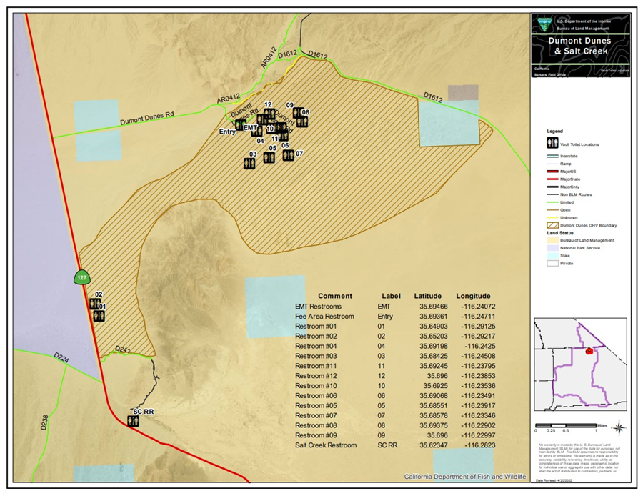

EX 2: Stoddard Valley OHV Area CXT Vault Toilet Map
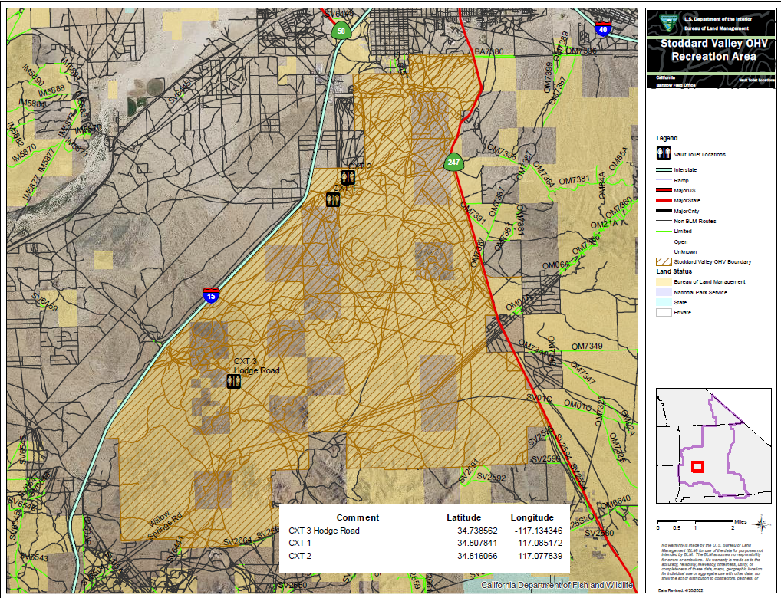

EX 3: Johnson Valley CXT Vault Toilet Map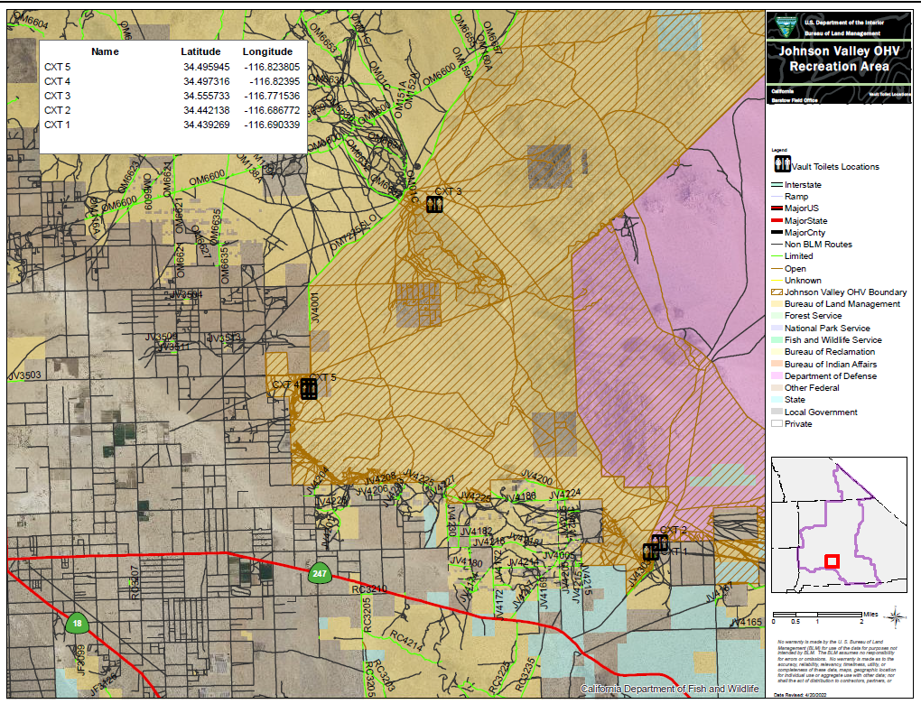

EXHIBIT X: QUALITY ASSURANCE SURVEILLANCE PLAN (QASP)

Work Tasks to be Performed | Acceptable Quality Level | Method of Surveillance | Consequences, Remedies, and/or Deduction(s)
Task(s) 1-4 | No more than 1 unsatisfactory inspection result per week. | The COR or another Government Representative will inspect the facilities in-person once per week. | For 1 unsatisfactory inspection, the COR will document this and inform the Contractor what must be improved.  For 2 unsatisfactory inspections, a 5% deduction from the invoice for that Period of Performance.  For 3 unsatisfactory inspections, a 10% deduction.

